Mark Remembrance Day with a Poppy download

Nottingham City Council is asking local schoolchildren to download a poppy, colour it in and place it in their window to mark Remembrance Sunday (8 November) and Armistice Day (11 November).
Like so many things this year, the Poppy Appeal has had to adapt to the threat of Covid-19. The Royal British Legion is asking public to support like never before, because every poppy counts.
With some people unable to leave their homes as they normally would to find a poppy, and with many of the charity’s collectors unable to carry out face to face collections, there is a range of new ways for people to show their support remotely.

From donating for poppies through the post for your neighbours and local community, displaying a poppy in your window, donating online or undertaking a virtual Poppy run, there are many ways to support the Poppy Appeal from home in line with Covid-19 restrictions.

More information along with the poppy download can be found at:
https://www.poppyshop.org.uk/products/download-a-remembrance-poppy

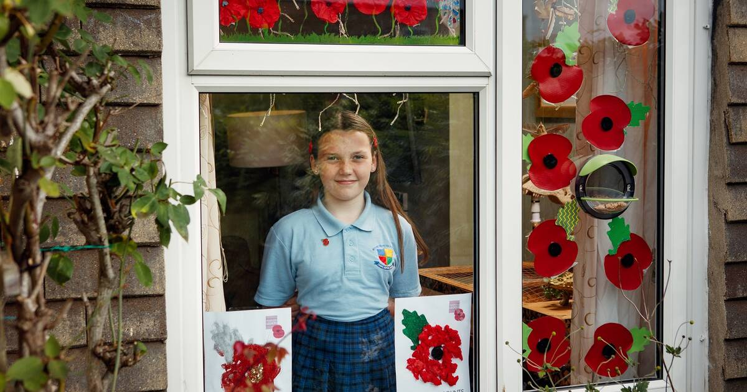
Image courtesy of the Royal British Legion

