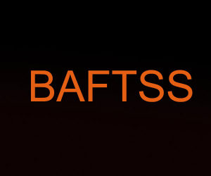

British Association of Film,
Television and Screen Studies

The BAFTSS Executive Committee operates subject to the Constitution (2015) and consists of 4 named officer roles (Chair, Vice Chair, Treasurer, Secretary) and a number of additional members. All of these positions are elected.
Where necessary, EC members will have expenses reimbursed when they attend EC meetings, AGM etc.

Responsibilities of EC Members

- Attend the four EC meetings: usually held in January, April, July and November.

- Assume responsibility for roles as decided by the EC such as:

  - Judging BAFTSS Awards (books, journals etc.)
  - Assessing submissions to Conference.
  - Assisting with Chairing etc. at Conference where possible.
  - Occasionally attending meetings on behalf of BAFTSS.

