Generating EBVs for postnatal lamb survival

Can we select animals for improved lamb survival?
The Challenge
Lamb survival is an important issue for the UK sheep industry due to the impact it can have on animal welfare and flock profitability. Although influenced by a wide range of different factors, the genetic component is worthy of consideration to allow the identification and selection of animals with improved lamb survival genetics.
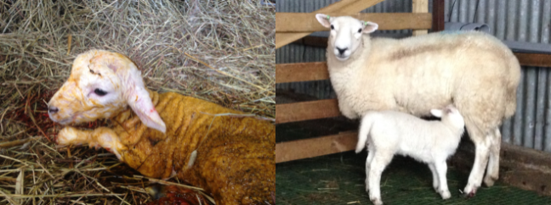
The Research
Data available from performance recorded Scottish Blackface, Dorset, Lleyn and Texel flocks, through the Signet Sheepbreeder Scheme, were used to investigate lamb survival. Lambs that had a live weight recorded either at 8- or at 21-weeks of age were classed as alive, where as those without a weight recorded were deemed to have died.
Birth
Mid-lactation
~ 8 weeks
Weaning
~ 21 weeks weeks

The Results
Using data recorded between 2003-2013 (between 2006-2011 for the Scottish Blackface) the proportion of lambs without a live weight recorded at 8- or 21-weeks of age ranged between 10-13%.
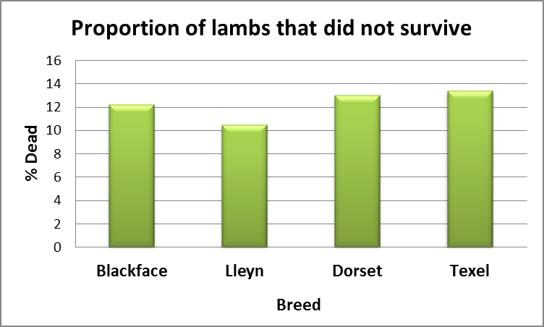
The heritabilities estimated for lamb surival (ie. the strength with which the trait is inherited), were found to be between 6% and 9%, indicating that genetic improvement for this trait is possible.
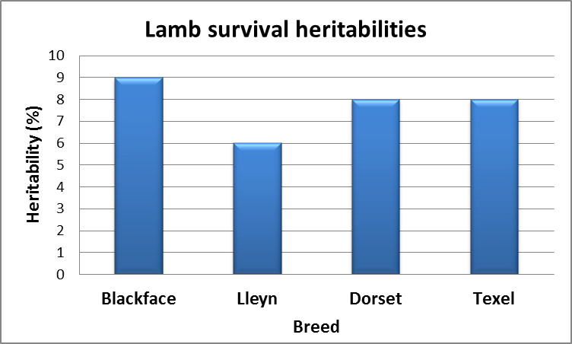
The Impact
These findings suggest that it is possible to identify animals and families with genetics favourable for lamb survival, thus allowing improvements in both survival rates and therefore flock profitability. Further improvements in the level of recording, particularly of dead lambs the birth weights of both dead and live lambs may prove beneficial to increase our knowledge of this trait further.

Project Detail
Project start date: [03/2015], finish date: [03/2016].
Email: Joanne.Conington@sruc.ac.uk. Joanne Conington and Ann McLaren, SRUC, West Mains Road, Edinburgh, EH9 3JG.
The Agriculture & Horticulture Development Board (AHDB) Beef and Lamb has funded this project. Many thanks also to Signet Breeding Services for providing access to the data.
Summary printed [*].

