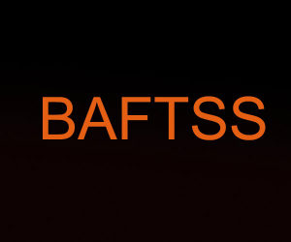

British Association of Film,
Television and Screen Studies

Responsibilities of the Chair**

1. EC meetings held in January, April, July and November:
- Chair EC meetings.
- Prepare a Chair’s Report (Standing Item on Agenda) updating EC on activities.
- At April EC, ensure all necessary arrangements are in hand for AGM, including Elections, Chair’s Report, and any Constitutional arrangements.
- Where any matters are put to the EC for a vote, in the case of a draw that cannot be resolved otherwise, the Chair has an extra casting vote.

2. EC Minutes and Actions
- Carry out Action Points delegated by the EC to the Chair as early as possible.

3. AGM Meetings (held during Conference):
- Prepare Chair’s Report, in discussion with EC.
- Ensure Elections are run in fair and open fashion.

4. Extraordinary General Meetings (EGMs)
- The Chair will chair all EGMs. An EGM may be necessary to agree any proposed changes to the Constitution. Any EGM can most readily take place in the same session as the AGM (formally speaking, the AGM will be suspended temporarily so that Constitutional matters can be agreed during an EGM, after which the AGM will reconvene).

5. Year-round responsibilities
- Ensure activities of the Association accord with the published Constitution.
- Ensure activities of the Association and its members accord with the Association’s published Inclusivity Statement.
- Ensure the activities of the Association accord with its published Mission Statement.
- Represent the Association where required, to other associations, institutions and governing bodies.
- Respond on behalf of the Association to any communications.
- Liaise with Secretary and Webmaster to ensure all agreed Minutes of AGM and EC meetings are posted to the website.

4. Diary

- December, March, June, October: liaise with Secretary to ensure dates, times of EC Meetings are circulated to EC, and that paperwork is circulated. This is ahead of the EC Meetings, which are usually in January, April (AGM), July, November.
- February: ensure arrangements in place for any forthcoming Elections (positions advertised on email list in timely fashion, paperwork in place for AGM etc, in line with Constitution).
- April: ensure paperwork in place for AGM, in advance of discussion at April EC.

** The Vice-Chair will deputise for the Chair where necessary.

