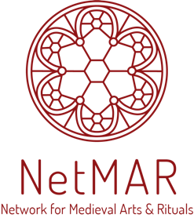

NetMAR Blog Template for Contributors

NetMAR is committed to finding exciting and interesting ways of communicating scholarship and original research to the community. As part of its mission of sharing insights by its expert affiliates to the community and to stirring and striking conversations between different actors – from academia, industry, policy-making bodies, and new enterprises – NetMAR is publishing monthly posts on its blog (www.netmar.cy/blog) beginning on 30 May 2021 and appearing at the end of each subsequent month thereafter.

We thank you for your interest to write a post for our blog. Please aim for something around 1500 words and remember to make your posts as accessible to a broad community as possible.

Please fill in the below details and send them alongside your post; this would help us during the process of uploading your post on the blog.

Name and affiliation

Title of post

Short abstract (55 words) – this will appear as excerpt on the website

Suggested image for use on the blog (please provide a link) and a short caption/copyright info/source

BLOG POST

